List of corrections

|  |  |
| --- | --- |
| 2 tabs are not created |  |
| Tab for work visa | I WILL RE SEND THE CONTENT |
| faq’S | I WILL RE SEND THE CONTENT |
| IN TAB CONTACT US FORM IS NOT LINK WITH GMAIL ACCOUNT OR ANY GOOGLE SHEET | PLEASE DO IT |
| SOCIAL MEDIA HANDLES ARE NOTCONNECTED | 1 WILL PROVIDE ALL THE HANDLES |
| IN SERVICE TAB | CONTENT FORMAT IS  VISA  VISA TYPE  (please interchange it) |
| Study tab | Categorised country ( including all countries)  Catergorised tranning ( including the exam details) |
| Company name | PRERNA GLOBAL IMMIGRATION SERVICES PVT.LTD |
| HOME PAGE | LEARN MORE BOTTON IS NOT WORKING |
| CHANGE THIS NUMBER (9811592101) WITH | ( 7082109920) |
| ADD A PAYMENT OPTION | A SEPARATE TAB |

BASIC WEB SITE INTERFACE IDEA THAT IS EXPECT :

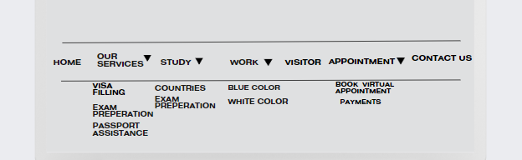

Please consider the list patter only the text and color you give is perfect.

Contact us TAB

* Form is not link with the g mail id or any google sheet .

G mail id : [info.prernaglobal@gmail.com](mailto:info.prernaglobal@gmail.com)

* I will give some frequently asked ques in a separate document format please add them below the enquiry form .

With this contact us tab / web page is completed .

APPOINTMENT TAB

A SEPARATE VIRTUAL MEETING IS CREATED AND LINKED IT WITH G-MAIL([info.prernaglobal@gmail.com](mailto:info.prernaglobal@gmail.com)) OR MOBILE NUMBER (917015131577).

Meeting details include:

|  |  |
| --- | --- |
| Name - |  |
| Timmings - |  |
| Phone number- |  |

2. payments method :

Add a page through which clients can able to pay for their services and please share the details that you need for this.

Visit tab

LIST OF COUNTRIES FOR WHICH WE WORK AT PRERNA:

INDONASIA ……..and many more (please add this)

WORK TAB

I will provide the content for this again please add that along with images

Study tab

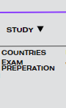 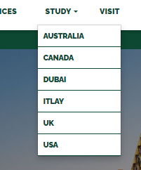

All the 6 countries that you mentioned are fall under the category of COUNTRIES IN the study tab .

Exam preparation section consists of info that I will provide .

Service tab

Just add two sub section like this 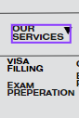

and when the user click on any of them so he just jump to that content of the page

And secondly please interswitch position of the contetnt with each other visa and visa type.

Home tab

company name is incorrect please change this

learn more botton is not working correct this

social media handles are not activated yet and also add you tube to our account :

Instagram: <https://www.instagram.com/prerna_global>

YouTube: <https://www.youtube.com/@Prernaglobal>

Facebook: <https://www.facebook.com/profile.php?id=100092726558233&mibextid=ZbWKwL>

Gmail: [info.prernaglobal@gmail.com](mailto:info.prernaglobal@gmail.com)

Twitter: <https://twitter.com/PRERNA_GLOBAL>

Phone number:

7015131577, 7082109920

Sir please check the the color theme also the color I decided is teal green and the color you give at top is dark green

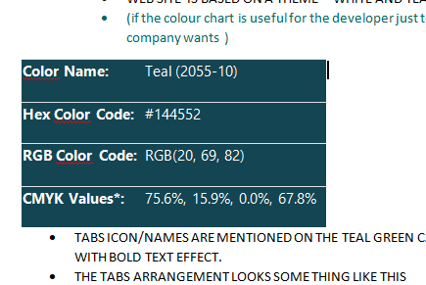

This is the actual shade of green that I want

